CoCo Driven Customer Persona Intelligence Platform
Problem Statement: Modern e-commerce platforms struggle to transform large-scale transactional data into real-time, actionable intelligence. Key challenges include:
- Delayed churn and payment fraud detection, leading to avoidable revenue loss
- Reactive fraud and RTO/cancellation handling, instead of proactive risk mitigation
- Lack of continuous seller performance monitoring, impacting customer experience
- Inefficient marketing spend, due to poor customer segmentation and targeting
- Fragmented data landscape, with no unified Customer or Seller 360 view
- Batch-driven analytics, resulting in decisions based on stale data
- Identify high-valued customers for cross sale strategy and predict customer purchase behavior
- Personalize marketing campaigns as well as Detect Inventory Inaccuracy
- Minimize Profit Trap due to High CAC(Customer Acquisition Cost), Channel Sync Disconnect
- Detect Synthetic Identity Fraud and Reduce ChatBot Gap for Customer Support

Solution Overview: A fully Snowflake-native, AI-powered intelligence platform that unifies customer, seller, order, and marketing data into real-time insights, predictions, and automated actions.

Platform Architecture
Layer | Description
Data Generation Layer | Synthetic yet realistic dataset covering 3K customers, 5K orders, 8K marketing interactions, and 200 sellers with relational consistency
360-Degree Gold Layer | gold_customer_360 and gold_seller_360 tables providing unified views across behavioral, transactional, and engagement data
AI Enrichment (Cortex) | AI-driven intelligence using Snowflake Cortex: persona classification, fraud detection, RTO prediction, sentiment analysis, and embeddings
RFM Segmentation Engine | Customer segmentation using Recency-Frequency-Monetary scoring with Cortex-based classification (Champions, At Risk, etc.)
Forecasting Engine | Predictive insights including churn risk, CLV, revenue forecasting, seller performance trajectory, and intervention recommendations
Real-Time Processing Layer | Continuous ingestion using Snowflake Streams + Tasks, with Dynamic Tables for near real-time aggregation and forecasting
Application Layer (Python) | Streamlit-based interactive dashboard enabling self-service analytics, alerts, and AI-driven insights

Key Capabilities

🔹 Customer Intelligence

RFM-based segmentation and persona classification
- Customer 360 profiling with behavioral and transactional KPIs
- Churn prediction, CLV estimation, and upsell recommendations

🔹 Seller Intelligence
- Revenue, profitability, and operational health tracking
- Seller performance monitoring and risk scoring
- AI-generated summaries and business recommendations

🔹 AI-Driven Insights (by Cortex Code)
- Summarization, sentiment analysis, and classification
- Key insight extraction and multilingual translation
- Natural language reasoning using COMPLETE (snowflake-arctic)
- Embedding generation for semantic analysis

🔹 Real-Time Analytics
- Automated processing using Tasks (1-minute intervals)
- Continuous data ingestion using Streams (CDC)
- Dynamic Tables for near real-time dashboards (5-min refresh)

🔹 Interactive Dashboard (Python)
- Built using Streamlit + Snowpark + Plotly
Multi-tab interface:
  - Alerts (threshold-based monitoring)
  - Customer Insights
  - Seller Insights
  - Combined Analytics
  - Forecast Views
- Replaces traditional BI tools like Power BI with a Python-native analytics application

Technology Stack
Data Platform |  | Snowflake
AI/LLM |  | Snowflake Cortex (COMPLETE, SUMMARIZE, SENTIMENT, CLASSIFY_TEXT, EXTRACT_ANSWER, TRANSLATE, EMBED_TEXT)
Data Processing |  | SQL (Snowflake), Snowpark
Real-Time Pipeline |  | Streams, Tasks, Dynamic Tables
Application Layer |  | Python (Streamlit, Plotly)

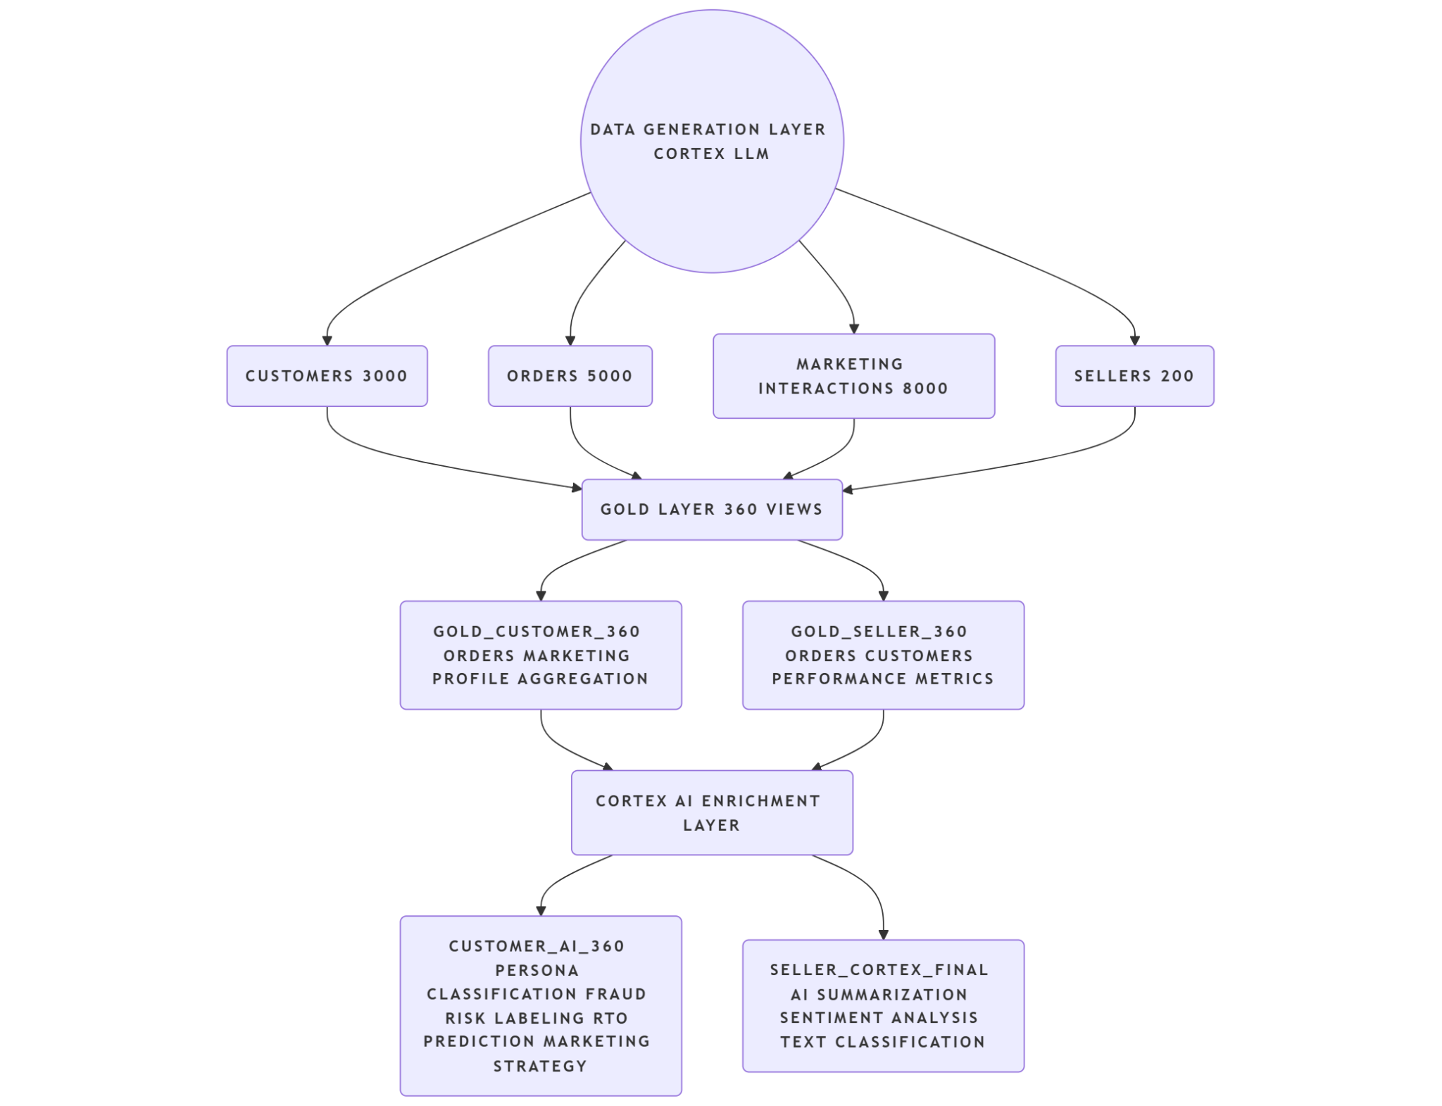

Future Enhancements
- Real Data Integration: Replace synthetic data with live event streams (Kafka, S3, Snowpipe)
- Advanced ML Models: Train models (XGBoost, LightGBM) using Snowpark ML for churn, fraud, and RTO prediction
- Cortex Search: Enable natural language querying for business users
- Alerting System: Integrate notifications via email/Slack
- Semantic Layer: Build Cortex Analyst layer for business-friendly querying
- Data Quality Monitoring: Implement Snowflake DMFs for validation
- Cost Optimization: Optimize warehouse sizing, refresh frequency, and task scheduling
- Access Control: Implement RBAC for secure, role-based data access

